Trent Giever

CS &141

Ch 4

4/12/2020

Problem # 8

Code:

///////////////////////////////////////////////////////////////////////

/\*

Programmer: Trent Giever

Assignment Chapter: 5

Purpose: The greatest and least loop

Date modified: 4/20/2020

IDE/Tool used: NetBeans 8.2

\*/

package ch.pkg5.pkg1;

import static java.lang.System.out;

import java.util.Scanner;

public class Ch51

{

public static void main(String[] args)

{

int user = 0, max = -99, min = -99; //sets variables

do

{

Scanner in = new Scanner(System.in);

out.println("Please enter a number: ");

user = in.nextInt(); //users input

if(user == -99) //see if -99 to print results

out.println("The results are: Max: " + max + " Min: " +min);

else if(max == min && max == -99) //first time in the loop

{

max = min = user; //sets max and min to the same value

}

if(user < min) //see if a smaller number

min = user;

if(user > max) //see if a larger number

max = user;

} while(user != -99);

}

}

Snip:

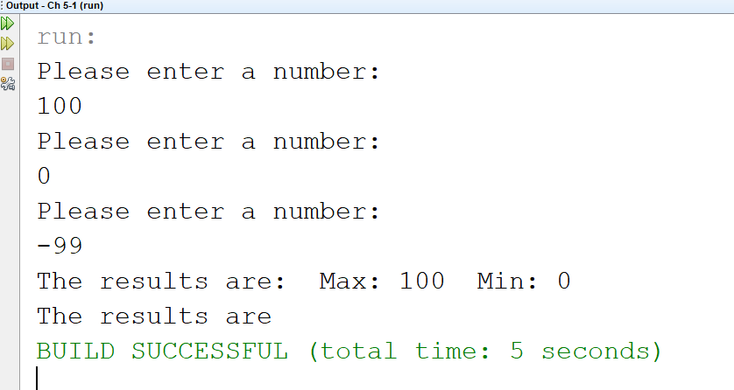

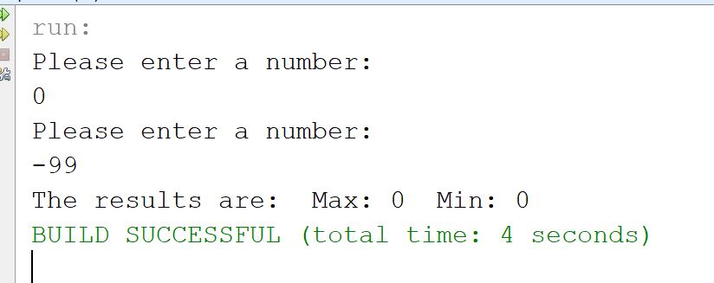

Program # 15

Code:

///////////////////////////////////////////////////////////////////

/\*

Programmer: Trent Giever

Assignment Chapter: 5

Purpose: uperCaseLowerCase Class

Date modified: 4/20/2020

IDE/Tool used: NetBeans 8.2

\*/

package ch.pkg5.pkg2;

import java.io.IOException;

import static java.lang.System.\*;

public class Ch52

{

public static void main(String[] args) throws IOException

{

//reads in the file with text, and creates a file for the write to

String read = "C:\\Users\\trgie\\OneDrive - Columbia Basin College\\CS 141\\Ch 5\\Ch 5-2\\src\\ch\\pkg5\\pkg2\\lowercase.txt";

String write = "C:\\Users\\trgie\\OneDrive - Columbia Basin College\\CS 141\\Ch 5\\Ch 5-2\\src\\ch\\pkg5\\pkg2\\uppercase.txt";

UpperCaseFile myFile = new UpperCaseFile(read, write); //creates object and will auto run

out.println("Your data has been uppercased");

}

}

/////////////////////////////////////////////////////////////////////

package ch.pkg5.pkg2;

import java.io.File;

import java.io.IOException;

import java.io.PrintWriter;

import static java.lang.System.\*;

import java.util.Scanner;

public class UpperCaseFile

{

File read, write;

public UpperCaseFile(String i, String o) throws IOException

{

read = new File(i);

write =new File(o);

run();

}

public void run() throws IOException

{

if(!read.exists()) //sees if read exists

{

out.println("Error! Check file name");

exit(0);

}

Scanner in = new Scanner(read); //file read in object

PrintWriter out = new PrintWriter(write); //file read out object

while(in.hasNext()) //loops through the files

{

String inputline = in.nextLine(); //assigns the line to a string

inputline = inputline.toUpperCase(); //makes uppercase

out.println(inputline); //writes to the file

}

//close files

in.close();

out.close();

}

}

Snip:

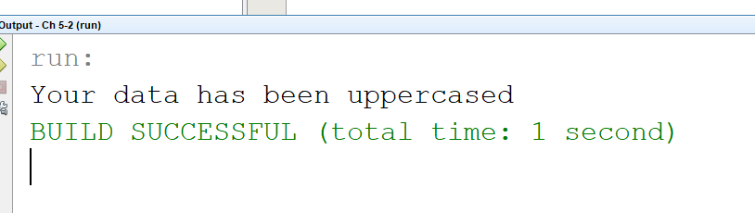

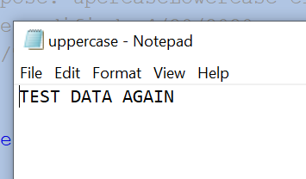

Program # 17/18

Code:

/\*

Programmer: Trent Giever

Assignment Chapter: 5

Purpose: Random Number Guessing Game

Date modified: 4/20/2020

IDE/Tool used: NetBeans 8.2

\*/

package ch.pkg5.pkg3;

import static java.lang.System.out;

import java.util.Random;

import java.util.Scanner;

public class Ch53

{

public static void main(String[] args)

{

int numGuesses =0, user =0; //variables to store count and user input

Random rand = new Random();

Scanner in = new Scanner(System.in);

int randomNum = rand.nextInt(100); //0-99 random number

out.println(randomNum); //display for testing

do

{

out.print("Enter a Guess: ");

user = in.nextInt();//user input

if(user == randomNum) //if equals

out.println("Correct!");

else if(user < randomNum) //if less thn

out.println("Too low, try again!");

else if(user > randomNum)//if greater than

out.println("Too high, try again!");

numGuesses++;

}while(user != randomNum);

out.println("Number of Tries: " + numGuesses);

}

}

Snip:

